To prevent the NutriScore Checkout Tool from breaking when running across distinct e-commerce platforms with varying text conventions, we must move away from evaluating raw, platform-specific string models.
An analysis of the scraped files reveals that unstructured front-end quirks can poison simple keyword mapping—for instance, the Naivas scraper occasionally captures promotional badge text (e.g., "product_name": "24% off") instead of the true brand title, while retaining a clean URL string (.../golden-drop-vegetable-oil-5ltr). Meanwhile, Quickmart uses precise tokens like "Quick Choice Sugar 1Kg".
The Unified Product Data & Schema Model below unifies these disparate sources into a clean, normalized relational architecture using a single source of truth linked via a canonical product reference.

1. Conceptual Relational-Style Architecture

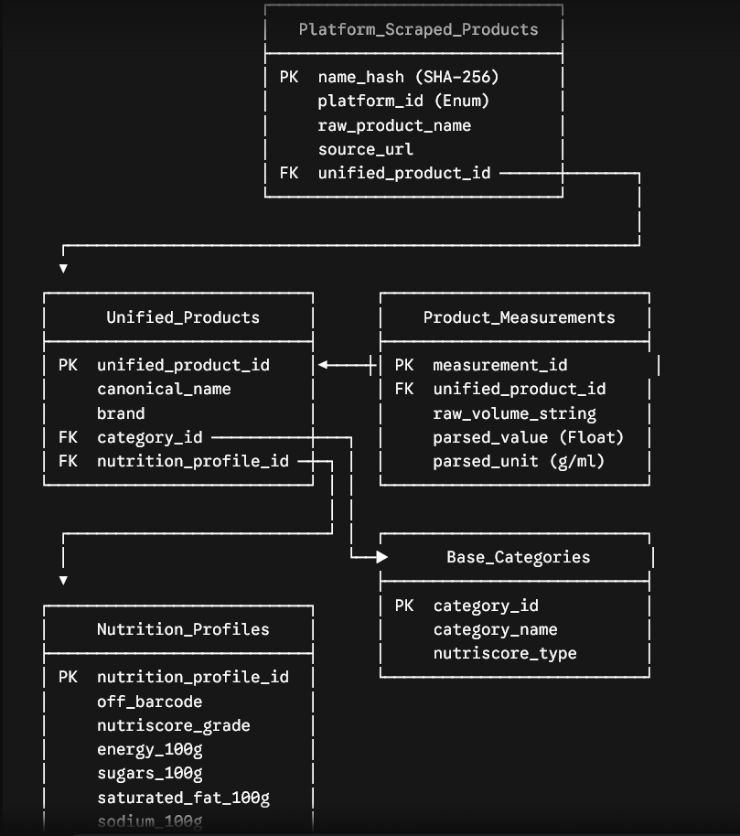 │ sodium_100g │
│ fiber_100g │
│ proteins_100g │
└───────────────────────────┘

2. Normalized JSON Database Schematics

A. Platform Scraped Products Mapping (platform_scraped_products.json)
This layer handles incoming extension requests. It absorbs all platform variance, maps dirty/corrupted scraping names using URL path fallback analysis, and links back to the canonical ID.

JSON
[
{
"name_hash": "4aa5ff4c68a4d7f6f499d7cf11af9447ecd374dce2f7ec5573bc15a4287a0a03",
"platform_id": "naivas",
"raw_product_name": "24% off",
"source_url": "https://www.naivas.online/golden-drop-vegetable-oil-5ltr",
"unified_product_id": "prod_can_goldendrop_veg_5000ml"
},
{
"name_hash": "aa872ec2a4d860fa5e8333c91c94067cf8228cb1392ff694b1446374b00ade8e",
"platform_id": "quickmart",
"raw_product_name": "Quick Choice Sugar 1Kg",
"source_url": "https://www.quickmart.co.ke/quick-choice-sugar-1kg-40",
"unified_product_id": "prod_can_quickchoice_sugar_1000g"
}
]

B. Canonical Products Base (unified_products.json)
The source of clean nomenclature, categorizations, and nutritional mappings.

JSON
[
{
"unified_product_id": "prod_can_goldendrop_veg_5000ml",
"canonical_name": "Golden Drop Vegetable Cooking Oil",
"brand": "Golden Drop",
"category_id": "cat_fats_oils",
"nutrition_profile_id": "nutr_profile_off_7356291"
},
{
"unified_product_id": "prod_can_quickchoice_sugar_1000g",
"canonical_name": "Quick Choice White Refined Sugar",
"brand": "Quick Choice",
"category_id": "cat_sugary_products",
"nutrition_profile_id": "nutr_profile_off_8410294"
}
]

C. Parsed Product Measurements (product_measurements.json)
Normalizes volumetric measurements to base-10 metrics (grams/milliliters) for precise evaluation.

JSON
[
{
"measurement_id": "meas_001",
"unified_product_id": "prod_can_goldendrop_veg_5000ml",
"raw_volume_string": "5ltr",
"parsed_value": 5000.0,
"parsed_unit": "ml"
},
{
"measurement_id": "meas_002",
"unified_product_id": "prod_can_quickchoice_sugar_1000g",
"raw_volume_string": "1Kg",
"parsed_value": 1000.0,
"parsed_unit": "g"
}
]

D. Base Categories Matrix (base_categories.json)
Mandatory taxonomy flags used to determine whether the standard Nutri-Score calculation must step into special baseline modes (such as beverages or added fats).

JSON
[
{
"category_id": "cat_fats_oils",
"category_name": "Fats and Oils",
"nutriscore_type": "added_fat"
},
{
"category_id": "cat_sugary_products",
"category_name": "Sugary Staples",
"nutriscore_type": "default"
}
]

E. Open Food Facts Macro-Nutrient Profiles (nutrition_profiles.json)
Maintains the raw 100g/100ml breakdown required to feed the mathematical calculations of the browser extension.

JSON
[
{
"nutrition_profile_id": "nutr_profile_off_7356291",
"off_barcode": "6194067cf8228",
"nutriscore_grade": "D",
"energy_100g": 3700,
"sugars_100g": 0.0,
"saturated_fat_100g": 14.0,
"sodium_100g": 0.0,
"fiber_100g": 0.0,
"proteins_100g": 0.0,
"fruits_veg_nuts_100g": 0
},
{
"nutrition_profile_id": "nutr_profile_off_8410294",
"off_barcode": "7613036271122",
"nutriscore_grade": "D",
"energy_100g": 1700,
"sugars_100g": 100.0,
"saturated_fat_100g": 0.0,
"sodium_100g": 0.0,
"fiber_100g": 0.0,
"proteins_100g": 0.0,
"fruits_veg_nuts_100g": 0
}
]

3. Verification & Extraction Fallback Pipeline
To parse irregular entries (such as 24% off or 12% off seen in the Naivas catalog), the background ingestion layer handles resolution using a deterministic fallback strategy before writing entries to the database:

JavaScript
function resolveScrapedItem(rawItem) {
let targetString = rawItem.product_name;
// Fallback Verification Step: If name is a structural discount leak, parse the URL slug
if (/^\d+%\s*off$/i.test(targetString.trim())) {
const urlTokens = rawItem.source_url.split('/');
const slug = urlTokens[urlTokens.length - 1] || urlTokens[urlTokens.length - 2];
// Transforms "golden-drop-vegetable-oil-5ltr" into clean text tokens
targetString = slug.replace(/-/g, ' ');
}
return normalizeMetadata(targetString);
}

4. Volume Regular Expression Rules for Kenyan Staples
The system standardizes product metrics into numerical fields using the following execution metrics:

JavaScript
function extractVolume(text) {
// Normalizes strings like: "2KG", "2Kg", "5ltr", "5L", "500G", "250g", "355ml"
const volumeRegex = /(\d+(?:\.\d+)?)\s*(kg|g|ltr|l|ml)\b/i;
const match = text.match(volumeRegex);
if (!match) return { raw: "unknown", value: 0, unit: "g" };
let val = parseFloat(match[1]);
let unit = match[2].toLowerCase();
// Transform metrics to standardized base values
if (unit === 'kg') { val *= 1000; unit = 'g'; }
if (unit === 'l' || unit === 'ltr') { val *= 1000; unit = 'ml'; }
return {
raw: match[0],
value: val,
unit: unit
};
}
This multi-tiered relational approach guarantees that the background script can safely query a single name_hash value sent from any retailer script, instantly resolve it to its core nutritional profile, and pass a reliable data packet back to the isolated Shadow DOM canvas.

